1. Perform the basic configuration setup for installing HADOOP 2.x like creating the HDUSER and SSH localhost

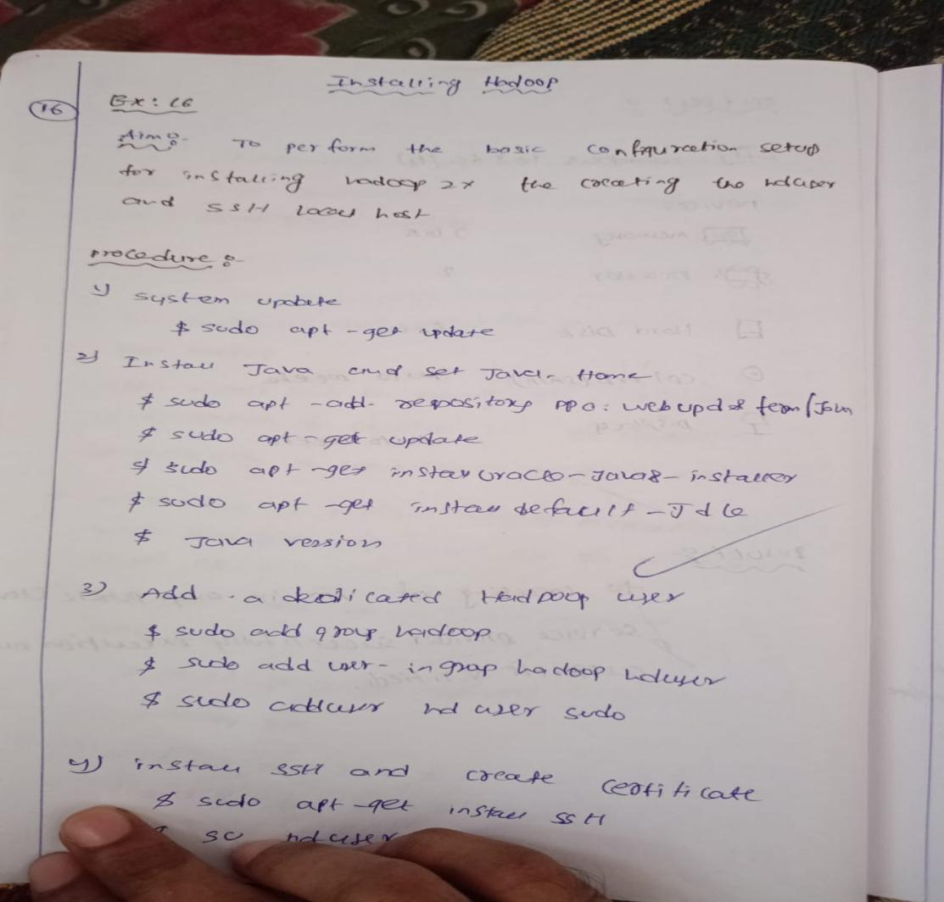

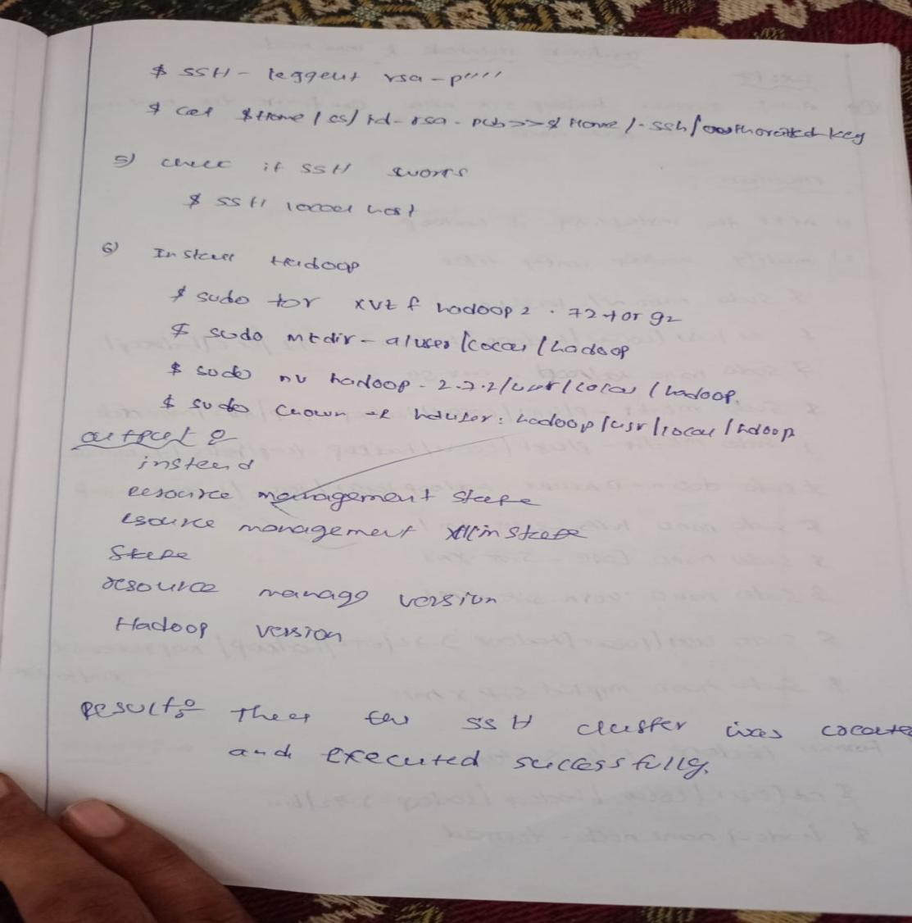

1. Install Hadoop 2.x and configure the Name Node and Data Node.

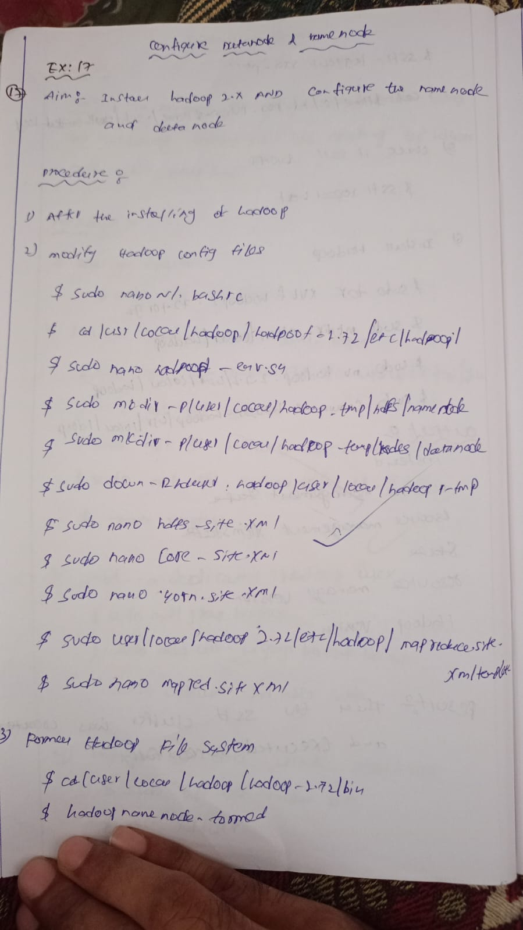



1. Launch the Hadoop 2.x and test the Map-Reduce Platform with Hadoop.

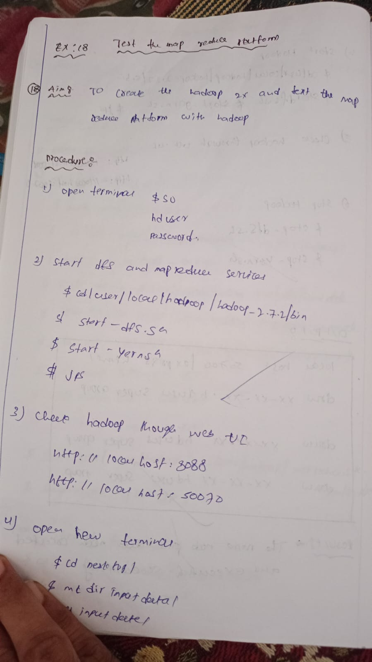

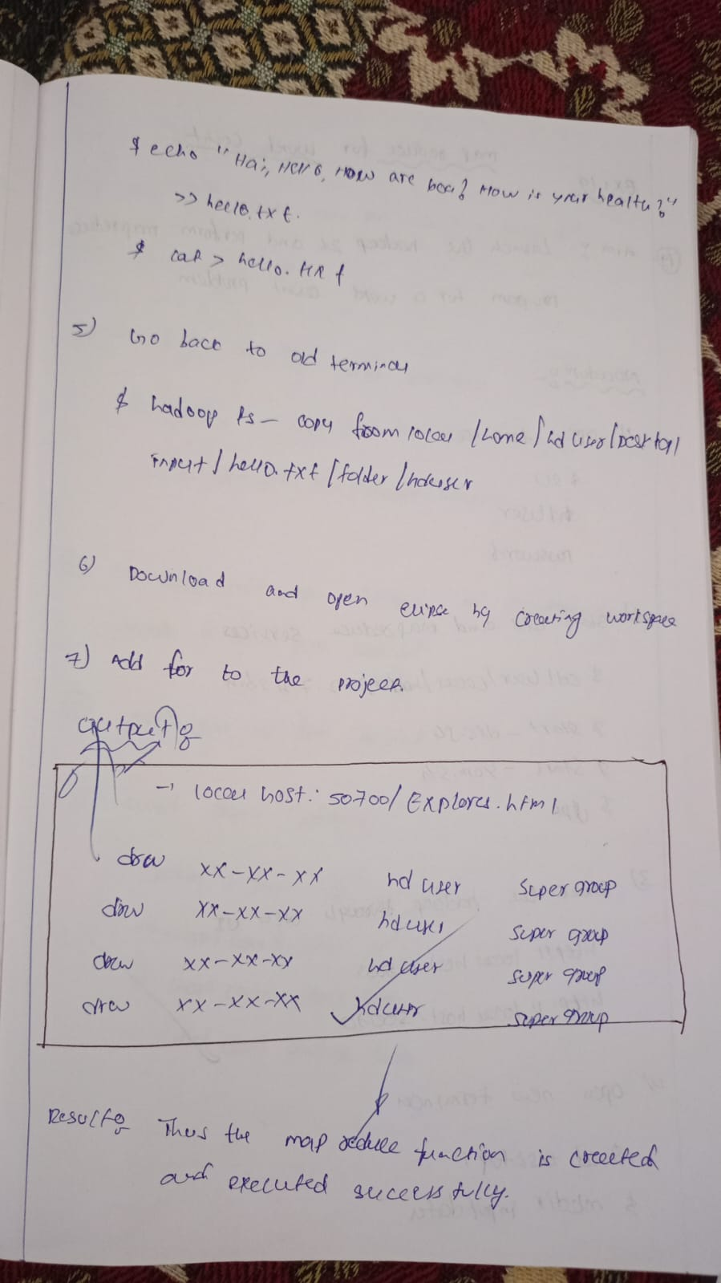

1. Launch the Hadoop 2.x and perform Map-Reduce program For a word count problem

